An Industry First: FAST® Extends Limited Lifetime Warranty To All E6 CD Ignitions

Memphis, TN – FAST® is proud to announce an ignition industry first. Beginning immediately, all FAST E6 CD ignitions will be backed by a full, limited lifetime warranty.

FAST®’s warranty represents what the brand has always been about — trust. It represents the trust we have in our products, our manufacturing methods and the quality of our designs and engineering. It also illustrates the continuing commitment we have to the highest quality standards and the respect we have for the racers and hot rodders who lay down their hard-earned cash on a product we believe in and are honored they chose.

“Though many may find a lifetime warranty surprising, especially in the high-performance and racing industry, we feel it’s an important statement to make on the commitment we have to our valued customers,” FAST® Ignition Product Manager Matt Patrick said.

For full warranty details, contact the FAST® tech line at 1-877-334-8355.
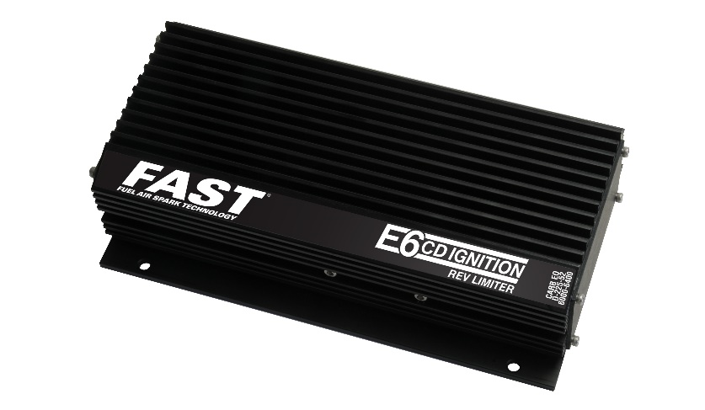
About FAST®
In 2001, FAST® was acquired by the COMP Performance Group™ and moved its headquarters to Memphis, TN, to become the popular electronics company that we know today. After more than a decade in the performance aftermarket industry, FAST® is the recognized leader in advanced EFI technology. Now, not only does FAST® offer the components to adapt virtually any engine to fuel injection, it is also an emerging force in the ignition market. With the latest in easy-to-use electrical components, the experts at FAST® have everything that you need to make high-tech horsepower. Additional information about FAST® and its products can be found at www.fuelairspark.com or at 1.877.334.8355. Also visit us on Facebook at facebook.com/FASTWins, on Twitter at twitter.com/FASTEFI or on YouTube at CPGNationTV.com.

Media Contact: Cindy Bullion, cbullion@compcams.com, 901.795.2400 ext. 1643.

